**On Designing an Intelligent Shipping Algorithm for Decentralized E-Commerce Systems**

Suneel Kumar 1,2,Sarvesh Pandey 2 and Umesh Bhatt2,3

1 Department of Computer Science, Institute of Science, BHU, Varanasi, UP, India

2Computer Science, MMV, BHU, Varanasi, UP, India

3 Indian Institute of Technology Madras, India

1suneel@bhu.ac.in, 2sarveshpandey@bhu.ac.in and

3umesh.bhatt2002@gmail.com

**Abstract.** The foundation of online shopping lies in the efficient and timely delivery of products from sellers to customers directly through a streamlined (and user-friendly) digital platform. However, transitioning to the online shopping platform leads to the following two problems: higher shipping charges and product handling fees levied by these platforms. The shipping charge is typically exempted if the order value is equal to or higher than the predetermined threshold value. The existing shipping charge exemption rule does not favor customers with low and mid-range budgets who often place orders valued lower than the threshold. To address the inherent biasness, we propose the History Informed Shipping (HIShip) method, establishing a fair business environment for all parties involved – the online shopping platform provider, sellers, and customers. HIShip intelligently utilizes the order history data, i.e., the cumulative sum of orders' value placed in the recent past, to make the shipping charge exemption rule friendly to low and mid-budget customers. Furthermore, it reduces biasness against vendors selling products that cost less than the threshold amount. Such a win-win scenario for the seller and customer eventually generates more revenue for the online shopping platform. We simulate the blockchain environment and use the TPC-H dataset to assess the performance. Our algorithm outperforms the threshold-based traditional approach.

**Keywords:** **Blockchain, E-Commerce, Intelligent Shipping, Smart Contract, and TPC-H**

1. Introduction

In the last few years, the technology underlying Bitcoin, called blockchain, has received remarkable attention from the industry and academia. Blockchain technology uses distributed records called a ledger, integrates consensus mechanism, decentralized data storage, encryption algorithm, peers, and use of computers to build new technology. Each peer in the network has a copy of all records. The concept of a chained structure within the blockchain renders the system immutable and transparent. Recently, blockchain technology has predominantly focused on the financial sector. Still, it also has led to tremendous changes in the non-financial sectors like e-commerce, e-government, supply chain, and credit evaluation.

A supply chain is a network of organizations and individuals involved in producing products and their delivery to the end user. The network is built with the producer, warehouse IN, transportation, warehouse OUT, retailers, and end-users (consumers). Nowadays, the network is spread worldwide. Supply chain management is the strategic and systematic coordination of the various components within the supply chain to ensure efficient, effective, and cost-effective operations. Several aspects could be explored regarding information related to security, transparency, and trustworthiness among users, retailers, suppliers, and manufacturers. The lack of transparency in the supply chain information results in a trust deficit between parties and hampers operations. Product tracking becomes challenging, particularly in cases where counterfeit and substandard products emerge. To encounter such types of problems, blockchain technology is best suited. Blockchain technology, while facilitating information transmission, ensures traceability and authenticity and provides a secure transaction in a distributed environment.

With the rapid development of online shopping, e-commerce platforms try to attract more and more consumers to purchase products from their respective shopping websites [1, 2, 3]. Suppliers promise to fulfill the user's requirements to reach their primary objectives. The E-commerce industry is predicted to surpass sales of $8 Trillion in 2026. India's e-commerce market is expected to reach 200 billion by 2026 [4], which is 2.5% of the total e-commerce industry value. Since 2020, the global COVID-19 pandemic-induced lockdowns have significantly catalyzed the expansion of the e-commerce sector. The analysis of data from the U.S. Department of Commerce shows that online consumer expenditure increased by 32.4% year over year in 2020. The transition from the traditional grocery system to the online grocery system is that online grocery shopping serves customers and manages home delivery. The consumers find the platform where they can get maximum benefits in terms of product price, quality, services, and delivery charges. In a traditional pricing model, users are entitled to complimentary delivery services when placing orders for high-priced products. When users engage in multiple transactions involving low-cost items, they are subject to incurring delivery charges with each order. Why do they not receive incentives in terms of delivery charges?

Milton asserts that the prevailing practice among online grocery retailers involves soliciting a delivery fee that amounts to only 80% of the total delivery cost. Undoubtedly, online grocers will not charge handling costs and internal shipping with customers. For instance, Whole Foods Market (WFM) announced free delivery for 2 hours in 2017 through Amazon Prime. Since October 25, 2021, WFM has been charging a delivery fee of $ 9.95 on every order to cover the handling cost associated. The shipping policy used by the grocer directly impacts the consumer's behaviors. The report [4] indicates that 95% of purchase decisions made by online consumers in the United States are influenced by shipping costs, with 63% of these decisions identified as primarily attributable to the abandonment of their shopping carts.

The online grocer uses a different strategy to mitigate the impact of shipping costs and motivate and retain more customers. For example, the goods and food delivery company Gopuff, which operates in the U.S. and England, charges a flat fee of $1.95 for each delivery. Walmart Grocery and Kroger Delivery charge flat fees depending on the user's location and speed. Yamibuy, Wee, Hungryroot, Walgreen, etc., are online grocers implementing the CFS (contingent free shipping). According to this policy, consumers are exempt from the delivery fee when their order value surpasses a specified threshold; otherwise, they incur a fixed-rate shipping fee. The marking analysis says that consumers typically do not make decisions about purchasing based on total price when product cost, handling cost, and shipping fee are separately charged.

A database benchmark is a crucial instrument for assessing the performance of research and practitioner data. These tools compare the performance of the different databases, software, hardware, and configurations to answer the common question of which system performs best in the specified domain for specific applications. Transaction Processing Performance Council (TPC-H) is a decision support benchmark. The TPC-H dataset is a synthetic dataset intentionally crafted to emulate real-world database datasets. It contains customers, orders, line items, and more to benchmark the business operations [5]. To assess the system's performance under varying workloads, we ingested different sizes of TPC-H order data, specifically sorting and ingesting 10K, 50K, 100K, and 500K orders based on the purchase date.

Smart contract

A simple contract is a legally binding agreement between two or more parties wherein they mutually commit to specific obligations or actions in the future. An ordinary contract is called a "smart contract" when it incorporates automated and self-executing functionalities by the terms and conditions specified in the agreement. Its primary characteristic is its capacity to eliminate the need for third-party intermediaries and establish trust through self-execution. For instance, John obtained a loan from a bank and entered into a contractual agreement with the bank. This agreement stipulates that the bank automatically deducts a predetermined sum from his account when his salary is deposited in his account at the end of each month. The computer program responsible for automatically deducting John's salary from his account by verifying and executing all the terms and conditions of the agreement is referred to as a smart contract [6]. The primary characteristics of blockchain technology (BT)— security, transparency, inalterability, immutability, and decentralization—have drawn the interest of the computing research community [7].

We developed a blockchain simulation using Python and Flask, with Flask providing a user-friendly interface. Python was used to develop the core components of the blockchain, including block creation, transaction validation, and chain management. The system was tested under varying workloads by ingesting different sizes of TPC-H order data. The 'free_delivery' attribute was computed for each transaction recorded on the chain. The PoW consensus algorithm was used for block validation and mining, ensuring security and immutability. The resulting blockchain was visualized to represent its structure and transactions. Tests were conducted with varying transaction volumes and complexity to assess the system's performance. The HIShip algorithm is implemented to determine eligibility for free delivery using a Solidity smart contract on the Remix IDE. We used dummy data of 20 customers and tested our algorithm on that, obtaining the same results as we did in the case of the Python-based blockchain simulation.

1. Related Work

In this part of the paper, we will describe the literature on e-commerce, explicitly addressing the optimization of delivery charges.

Shipping policy is a crucial entity in the online retailing system operations. The paper discusses the impact of different shipping policies and how they affect customers and retailers. In scenarios with several competing stores, the models are developed to observe how the quantity competes when shipping is free and how prices compete when shipping is computed. Retailers who shift their operations online and use a calculated shipping policy get nothing as an advantage. Smaller local merchants gain by going online and offering free shipping. In the e-commerce market with several competitive retailers, customers and suppliers both prefer the free shipping policy over the calculated policy. The experiment result shows that larger retailers are harmed by free delivery, while smaller stores may profit from it. [8].

One crucial challenge among the several challenges in e-commerce is communicating with the logistic companies incorporating the delivery services. To encounter such type of a problem, the paper presents the design of a system that evaluates the websites to help logistic companies in serving product delivery. Swift, an open-source object-oriented language, and HTML (Hypertext Markup Language) are used to develop the last-mile delivery system. The system used Firebase, a Google-backed real-time database, for streamlining development [9].

The rapid growth in communication technology development is driven by the increasing demand for sharing information and data across various sectors. The tourism sector requires communication technology to share views and data about tourist destinations so that new tourists can experience finding their intended destinations. However, the information and data related to the ranking of tourist places are exchanged through a central server. Centralized architecture has many limitations that are required to improve. The research article represents a TDRS (Tourism Destination Rating System), which has 6As (Accessibility, Attractions, Available Packages, Amenities, Activities, and Ancillary Services) T.D. metrics to assess the tourism destination. The review of the destinations is shared on each traveler's mobile device connected to the blockchain network. The model has been tested on many tourists [10].

Today's publishing system suffers from many issues, like long publishing delays and no fair financial credit distribution among the contributors. EUREKA is an open-access publishing platform with blockchain technology that provides fair credits to all publishing contributors directly via smart contracts. There are different interfaces for the authors and reviewers; the writer can submit the article. The judges who review the articles can give their opinions on the acceptance or rejection of the articles, and all the events will be executed through the Ethereum smart contract [11].

A circular economy focuses on the regeneration of resources rather than possession and suggests leveraging shared resources to build new economies and supply networks. Before collaborating on the circular economy, each entity must have the credit rating of the other. In this referenced paper, blockchain technology has been applied to transactions corresponding to the economic entity, and a confidence level method estimates the credit rating of each entity. The system provides a decentralized environment to optimize third-party involvement costs and enables the effective conduct of credit ratings [12].

Selecting a reliable shopping website is a challenging task for a user. The supplier and users may have different points of view regarding the product quality, leading to disputes between users and merchants. Purchasing the product based on images of the product or purchasing the product based on the merchant's claim to have a high-quality product may cause disputes. This dispute cannot be removed completely but can be optimized up to a certain limit, no matter what reputable companies a user selects, even Amazon.com and Alibaba.com. In all analysis conclusions, this problem is because the merchants do not evaluate the product based on the ratings. This paper proposes a grading system, BPGS (Blockchain-based Product Grading System), through which a customer can purchase a genuine product dealing with big data of business. Additionally, under the planned BPGS, 51% of assaults cannot be successful unless 51% of the alliance's retailers and e-commerce businesses are concurrently penetrated [13].

Extensive research and analysis have been conducted to comprehend customers' moods and behavior in online shopping. Researchers systematically analyze and endeavor to ascertain the factors influencing shoppers' behavior. These factors have a direct and immediate impact on the sales quantities. Two ordinary models have been developed with the dataset taken from the Kaggle repository, which estimates the effect of online revenue collections and visiting time in deciding to purchase the products. The result shows that, although time spent on the website was completely insignificant, time spent on the mobile application did have a minor impact on sales (R2 = 0.249) [14].

Online shopping users' personal information is important in driving an eCommerce business. It can be proved a significant element in differentiation among the organizations in the competition of business and may provide a well-defined strategy to provide more profits for the organizations. However, there is a challenging worry about the requirement of consumer data and the security of the user's desire for privacy. This research article explains the favorable and adverse effects on consumers' perceptions of privacy and trust. Also, a model of 301 online users has been tested who go through two online shopping websites and use one of them. The result is more oriented toward the positive effects on trust in privacy and websites. The idea of a positive mood in users' behavior toward the website's features has the potential to direct the creation of websites for efficient data collecting and information sharing [15].

An organization has sensitive data like corporate information, its staff's information, and customers' information, which can harm reputation and revenues tremendously. The paper highlights blockchain's value in safeguarding e-commerce data, surpassing traditional methods in securing the data, and providing transparency to maintain trust in the organization. It has integrated blockchain technology into the database of the e-commerce organization system to protect the data from breaching issues .

E-commerce faces challenges in transactions, data security, and transparency. Companies like MultiChain, Elinext, Eligma, Coupit, and Ravain are developing blockchain solutions. Blockchain improves efficiency with transparent, low-cost, and secure payment systems, empowering customers [2].

This paper presents a blockchain-based framework designed to address the product traceability challenge in cross-border e-commerce supply chains. The contributions of the paper are: 1. The introduction of a blockchain-based product traceability framework for cross-border e-commerce supply chains, offering theoretical and methodological contributions to the fields of blockchain technology and supply chain management theories. 2. Introduction of an innovative multi-chain structural model for blockchain system design. It involves an analysis of data characteristics to support the partitioning of multiple chains, making valuable contributions to the research areas of blockchain-based system design and data management [16].

This study explores how online shopping motivation and the type of product impact user behavior on e-commerce websites. It conducted a 2x2 factorial experiment with goal-oriented/experiential shopping motivations and hedonic/utilitarian product types. The results indicate an interactive effect: goal-oriented shoppers can buy hedonic products without guilt or regret concerning their budget [17]

1. Methodology

This section explores the methods and dataset to discuss our proposed work. The section is divided into three sub-major sections- existing work, proposed work, and implementation.

* 1. Existing work

Many e-commerce websites use different policies to provide the product to the customers so they can easily get it. However, the shipping fee is always a challenging task to handle. Many online grocery stores use the CFS (contingent free shipping) policies,hich are based on the threshold value [18]. Koukova et  al. explain how the customers respond to shipping policies that differ from flat-rate policies regarding threshold-based free shipment. [19] . Under this scheme, only all those customers who order the product above a threshold can get a free delivery charge product. The customer who orders the product at a meager price has to pay the shipping fee on each order, regardless of what amount they have ordered many times. This existing traditional method charges the shipping fee to those customers who make the orders at low prices but very frequently.

* 1. Proposed work

E-commerce websites face several challenges, one of which pertains to implementing a free delivery policy for the selection of customers to provide the product without a shipping fee. The current policy dictates that products are eligible for free delivery only when customers place orders exceeding a specified threshold amount. To encounter such a problem, we have proposed an HIShip algorithm that selects the customers to give the shipping charge free delivery product so that both retailers and customers can get benefits. The HIShip algorithm is based on the customer's previous order history. When a customer initiates an order for a product, our algorithm conducts an analysis of the customer's historical order data, performs requisite processing, and subsequently determines whether said customer qualifies for complimentary delivery or if they will incur shipping charges. The algorithm follows the blockchain paradigm to store the transaction into blocks and check into the transaction records whether the next transaction's product will be delivered without a shipping charge. To see the performance of our work, we have considered the TPC-H standard dataset. We have considered the varying number of records, e.g., 10K, 50K, 100K, and 500K, to test our proposed model and showed how our proposed algorithm performs better than the naïve approach.

* + 1. **Workflow components**

In Figure 1, how our work will be performed is briefly described, along with the associated components.

1. **Users** – It is a person who initiates the order by any device connected to the internet.
2. **Initial Order** –It contains data related to user orders.
3. **Final Order** – Besides the initial order, it contains a free delivery field.
4. **Blockchain** is a chain of block containing orders as transactions.

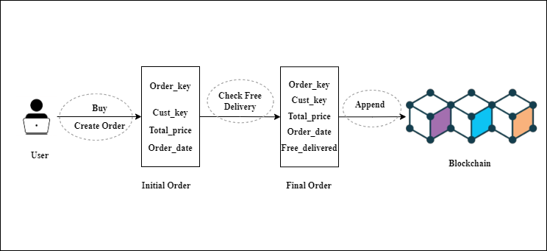  
Figure 1: The workflow of the proposed work

* + 1. **Workflow**

**1. Buy –** A user buys an item by sending order data using the buy function and creates an initial order that contains the attributes –

● Order_key

● Cust_Key

● Total_price

● Order_date

**2. Check –** The buy function will call the Check_delivery function sending (Cust_id, Price, Datework) to check whether the order is eligible for free delivery.

**3. Append-** The buy function will call the append function to append the transaction to the chain.

* + 1. **HIShip Algorithm Pseudocode**

|  |  |
| --- | --- |
| **Input:** | **Order(Cust_ID, Price, Time)** |
| 1 | total ← 0; flag←0; |
| 2 | For each Tx in Chain |
| 3 | If ( Order. time - Tx.time ) ≤ (1 Year) |
| 4 | If ( Order.cust_ID ==Tx.cust_ID) |
| 5 | If Order.Free_delivered==FALSE |
| 6 | total← total+Tx.price |
| 7 | Else |
| 8 | flag←1 |
| 10 | Else |
| 11 | flag←1 |
| 12 | If (flag==1) |
| 13 | break |
| 14 | If total + Order.price ≥ Threshold |
| 15 | Return TRUE |
| 16 | Else: |
| 17 | Return FALSE |

* 1. Implementation
     1. **Python-based Blockchain Simulation Framework**

Our blockchain simulation is implemented using Python and Flask as the primary technologies, with Flask providing the necessary web framework for creating a user-friendly interface for interacting with the blockchain simulation. The core components of the blockchain, including block creation, transaction validation, and chain management, were developed in Python. To assess the system's performance under varying workloads, we ingested different sizes of TPC-H order data, specifically sorting and ingesting 10K, 50K, 100K, and 500K orders based on the purchase date. One of the key functionalities of our blockchain simulation was to compute the 'free_delivery' attribute for each transaction recorded on the chain, a crucial feature for evaluating the free delivery option for customers. Our blockchain simulation implemented the PoW consensus algorithm [20] for block validation and mining, ensuring the security and immutability of the blockchain by requiring participants to solve computationally intensive puzzles before adding a new block to the chain. The resulting blockchain is visualized to represent its structure and the recorded transactions, as illustrated in Figure 2. To evaluate the performance and scalability of our blockchain simulation, we conducted tests with varying transaction volumes and complexity, essential for assessing the system's ability to handle a growing number of transactions while maintaining performance.

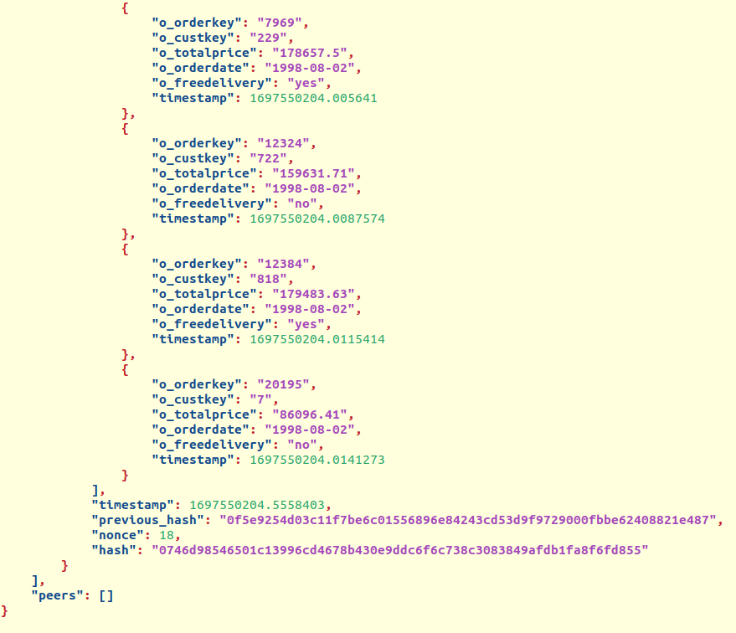

Fig. 2: Python-based Blockchain

* + 1. **Smart Contract-based Blockchain Simulation Framework**

In addition to the Python simulation, we also implemented our algorithm HIShip to determine the eligibility for free delivery using a Solidity smart contract on the Remix IDE [21].

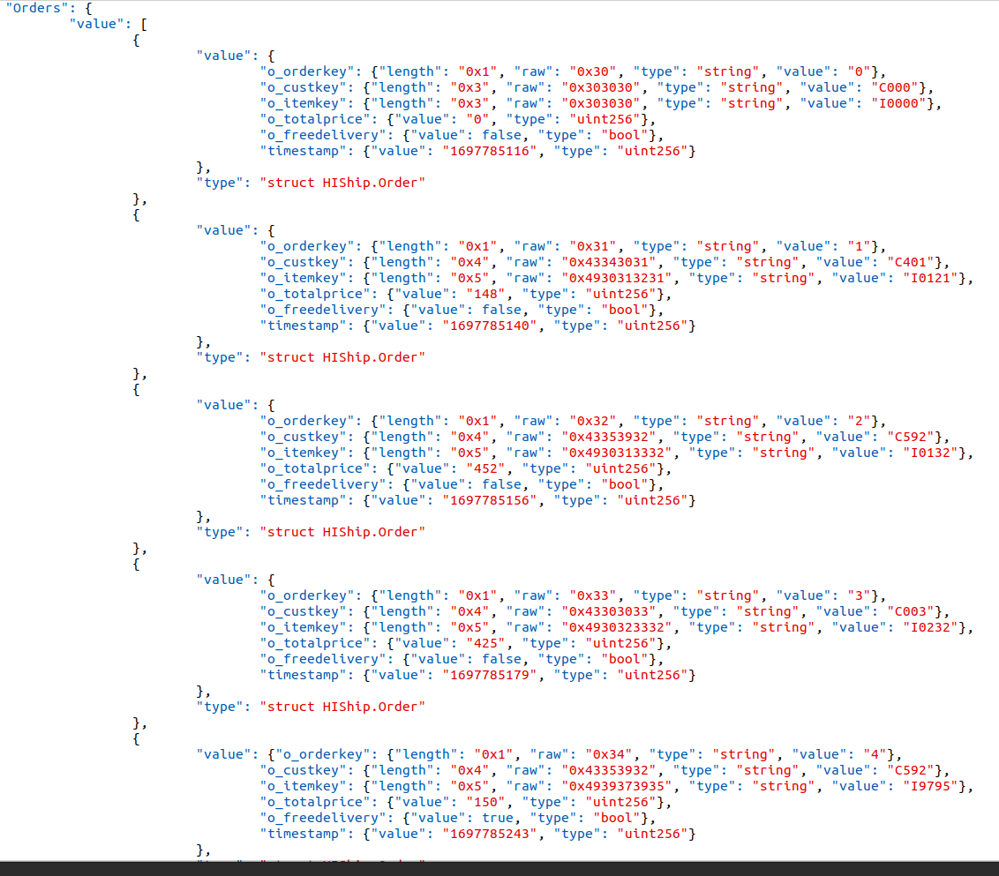

Fig. 3: Smart contract-based blockchain

This intelligent contract was tested using a set of 20 dummy data orders, and the resulting blockchain is depicted in Figure 3. This complementary aspect of our project extended the functionality of the blockchain simulation, enabling the verification of free delivery eligibility through a secure and decentralized approach within the blockchain network.

1. Performance Results

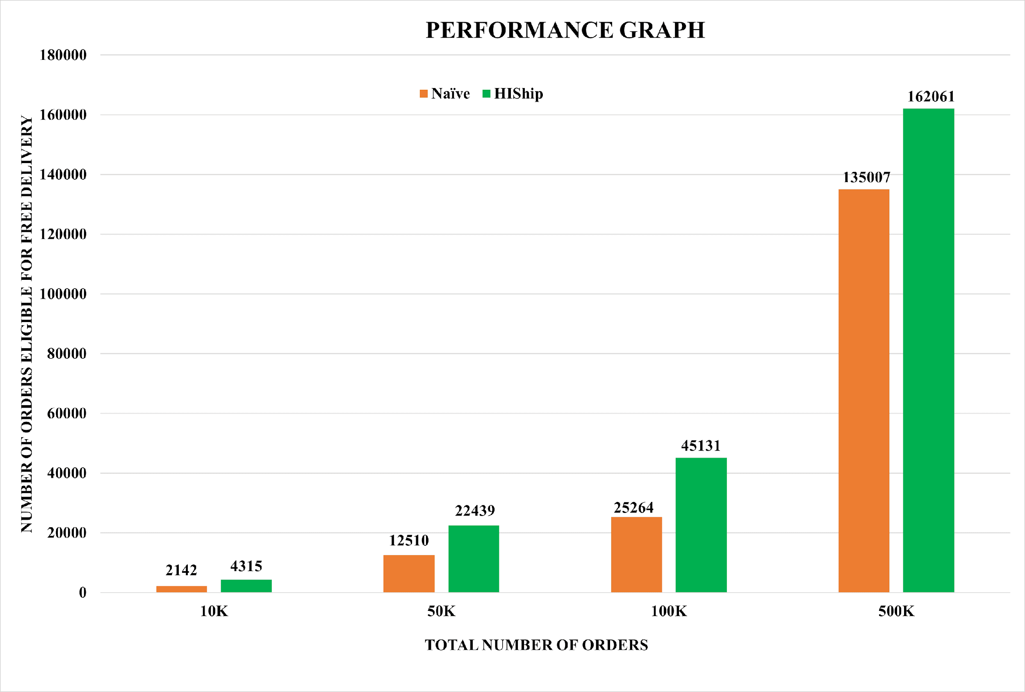

Figure 4: Performance comparison of our proposed algorithm HIShip with the Naïve algorithm.

In Figure 4, we have compared the total number of orders eligible for free delivery assigned by both algorithms. The blue column represents the naïve algorithm, while the orange column represents our proposed algorithm. In the Bar graph, we have considered the total number of orders on the X axis, and the Y axis signifies the total number of orders eligible for free delivery. The graph depicting performance data reveals that our newly proposed algorithm outperforms the current algorithm for delivering free services to customers. When examining the specific instances within a set of orders, it becomes evident that our proposed approach consistently demonstrates superior performance in each instance. In the initial instance involving 10,000 orders, the naïve algorithm confers the benefit of free delivery upon 2,142 orders. In contrast, our proposed algorithm surpasses this by extending this advantage to a more extensive set of orders, encompassing 4,315 orders.

In the same way, at the 50K number of orders, the naïve algorithm delivers 12510 ordered products without shipping fees. On the other hand, our proposed algorithm delivers 22439 ordered products without paying any delivery charges, which is nearly double in number to the existing naïve method. On running both algorithms at 100K orders, we found the free delivery on 25264 and 45131 orders by naïve and our approach. Out of a dataset comprising 500K orders, it is observed that the naïve approach results in 135,007 products being delivered without incurring shipping charges. At the same time, the HIShip algorithm exhibits a superior performance by facilitating the shipment of 162,061 ordered products without imposing shipping fees.

We have tested the performance of the HIShip algorithm and naïve algorithm on the 10K, 50K, 100K, and 500K orders separately. The primary purpose of running our algorithm in isolation is to conduct a performance analysis of the algorithm. We have divided each set of records into three categories: High, Middle, and Low values orders.

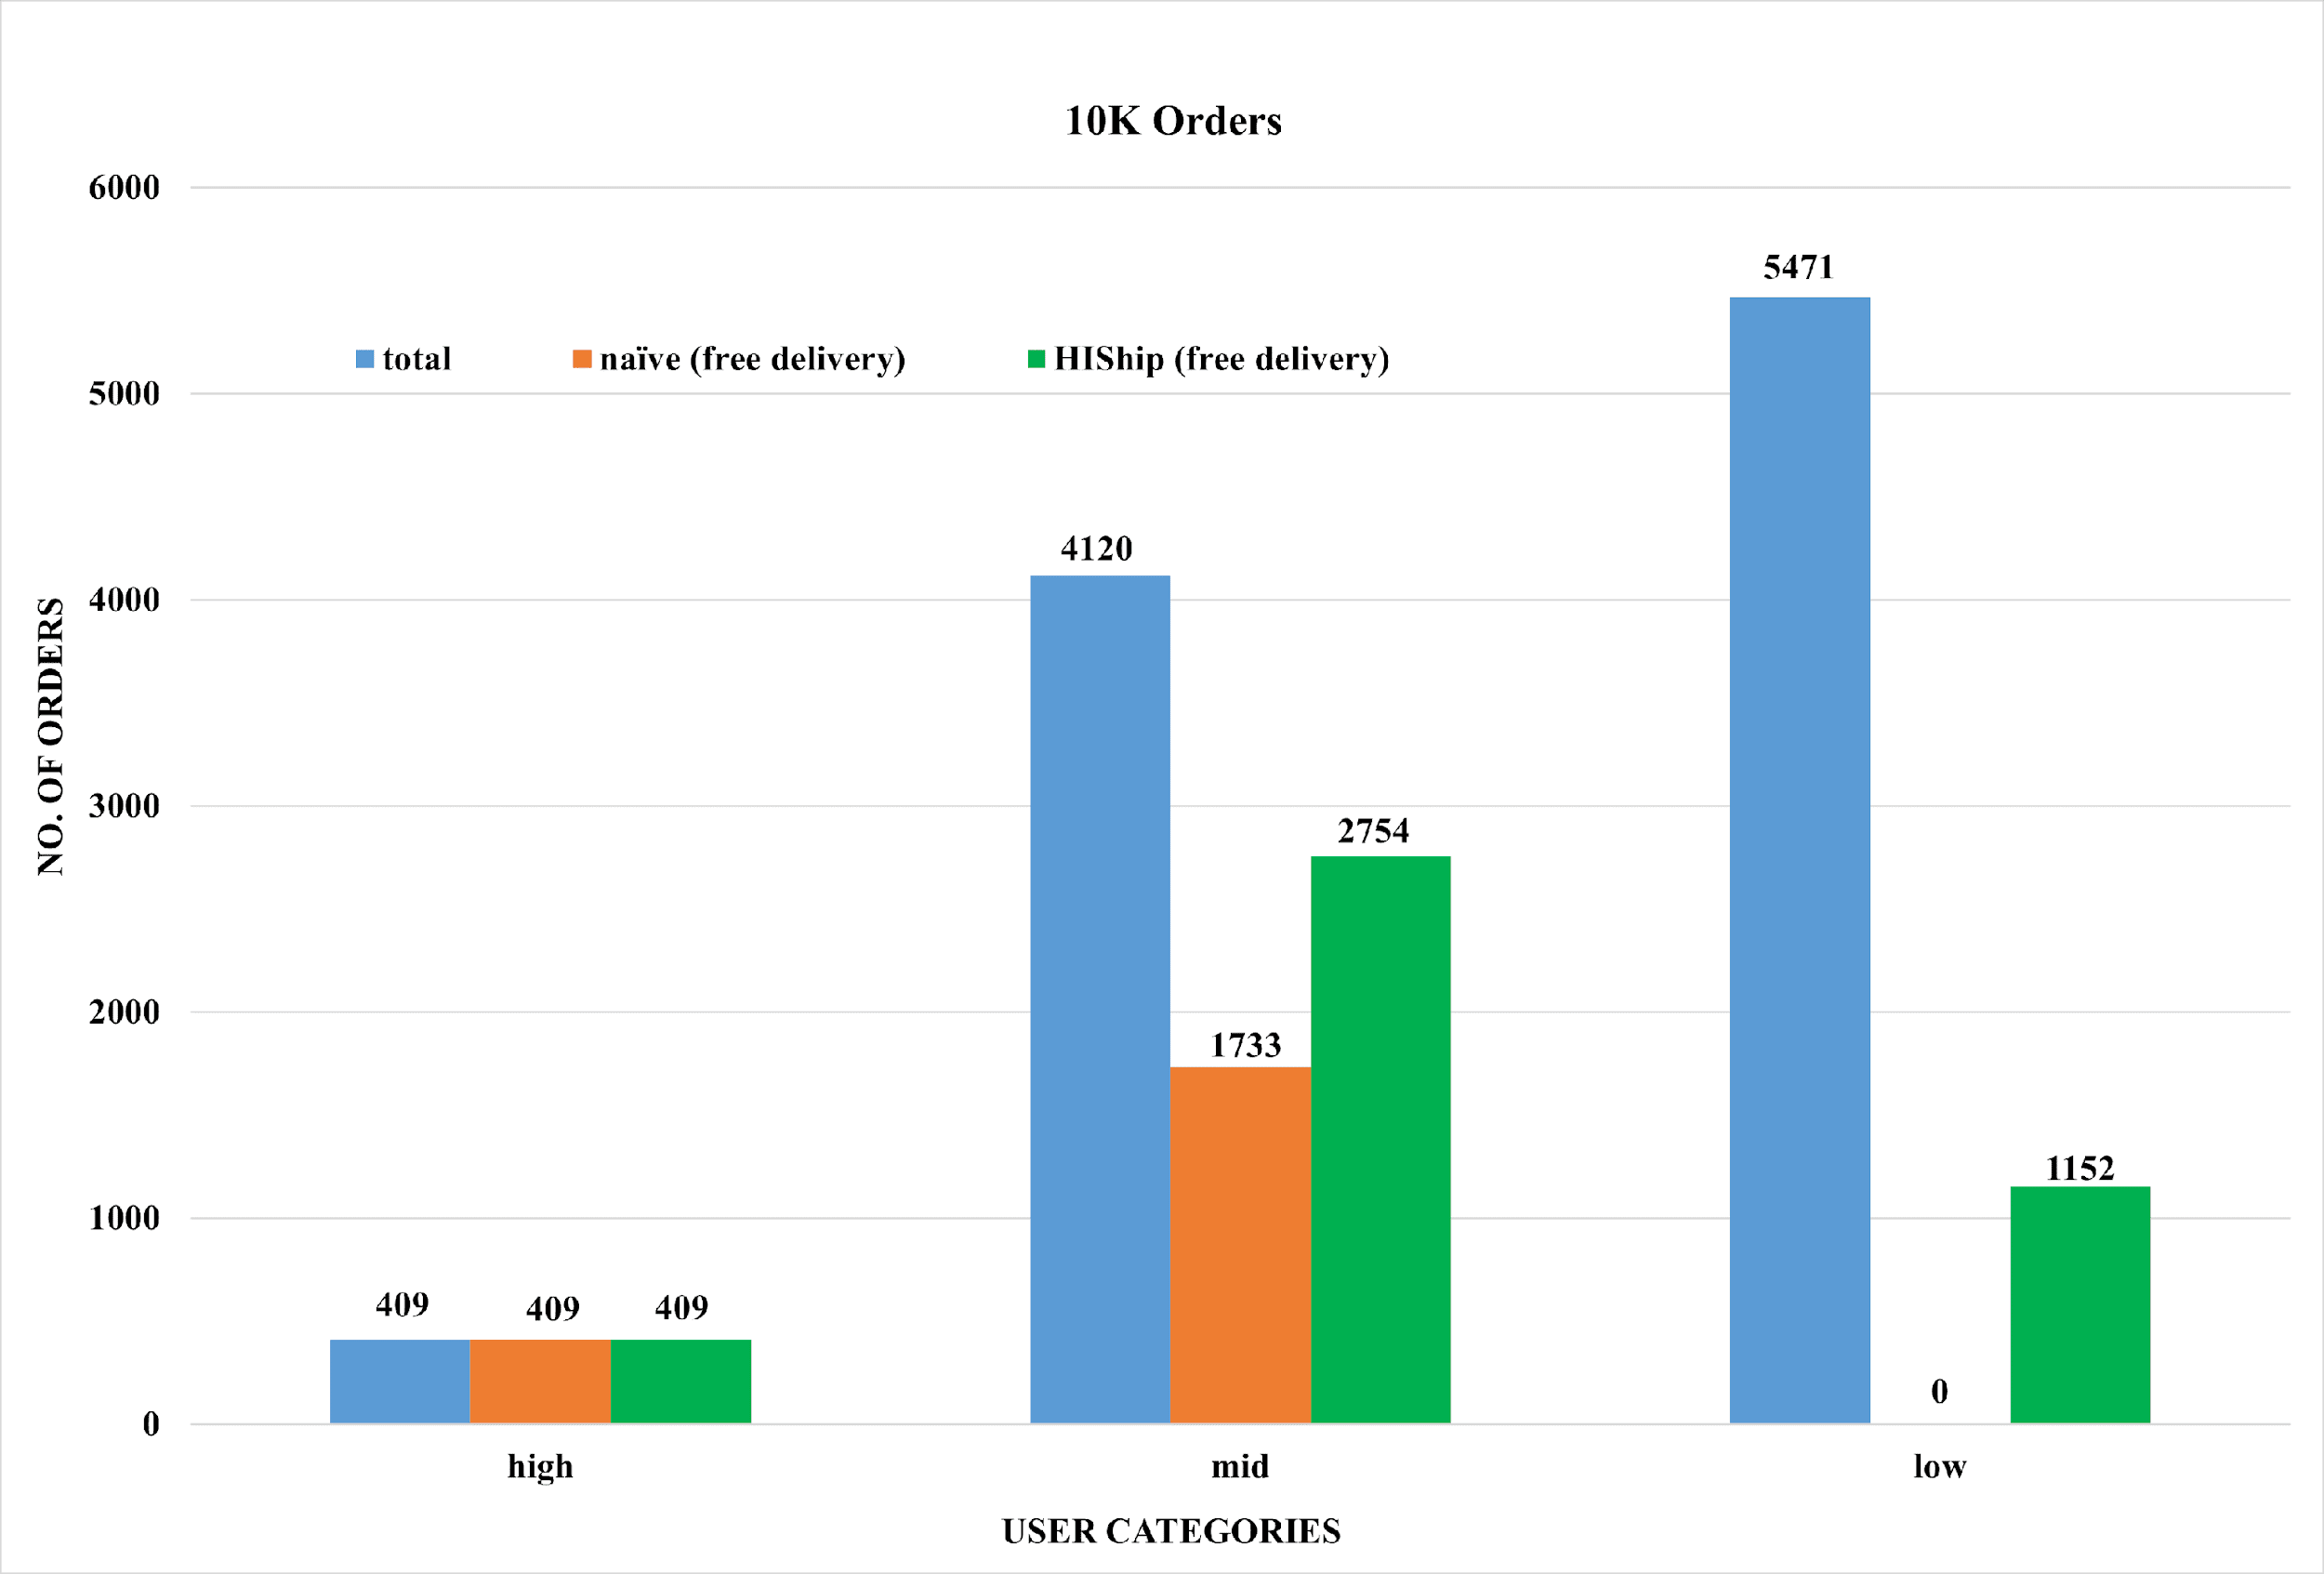

Figure 5: 10K Orders Classification & Delivery Eligibility: HIShip vs Naive

In Figure 5, a dataset of 10K orders is divided into three categories based on the number of transactions: the first category contains high-value orders, the second store's middle-value orders, and the remaining orders fall into low-value orders. In the bar graph, sky blue represents the total orders, orange shows the naïve approach to giving free delivery, and the green bar depicts the number of orders that provided free delivery in the case of our proposed algorithm. In this instance of a set of orders in the high category, there are 409 orders, and both the algorithm (the naïve approach and our proposed approach). But in the middle category, out of 4120 orders, the naïve approach provides 1733 orders without any shipping charge, while our proposed algorithm HIShip gives 2754 transactions as delivery charge-free products, which is 1021 more orders and is nearly 25% orders of the total orders. Hence, our proposed algorithm is more efficient than the naïve approach in the middle category. However, if we look at the data of the third category, which is the low amount category, we found that out of 5471 orders, the naïve algorithm does not provide any of the products without shipping charges. In comparison, our proposed method exempts 1152 orders with the shipping charge, which is an excellent performance of our proposed approach. Our algorithm's remarkable point and achievement is that it focuses on frequently ordered low-priced products and provides them with fee-free product shipping.

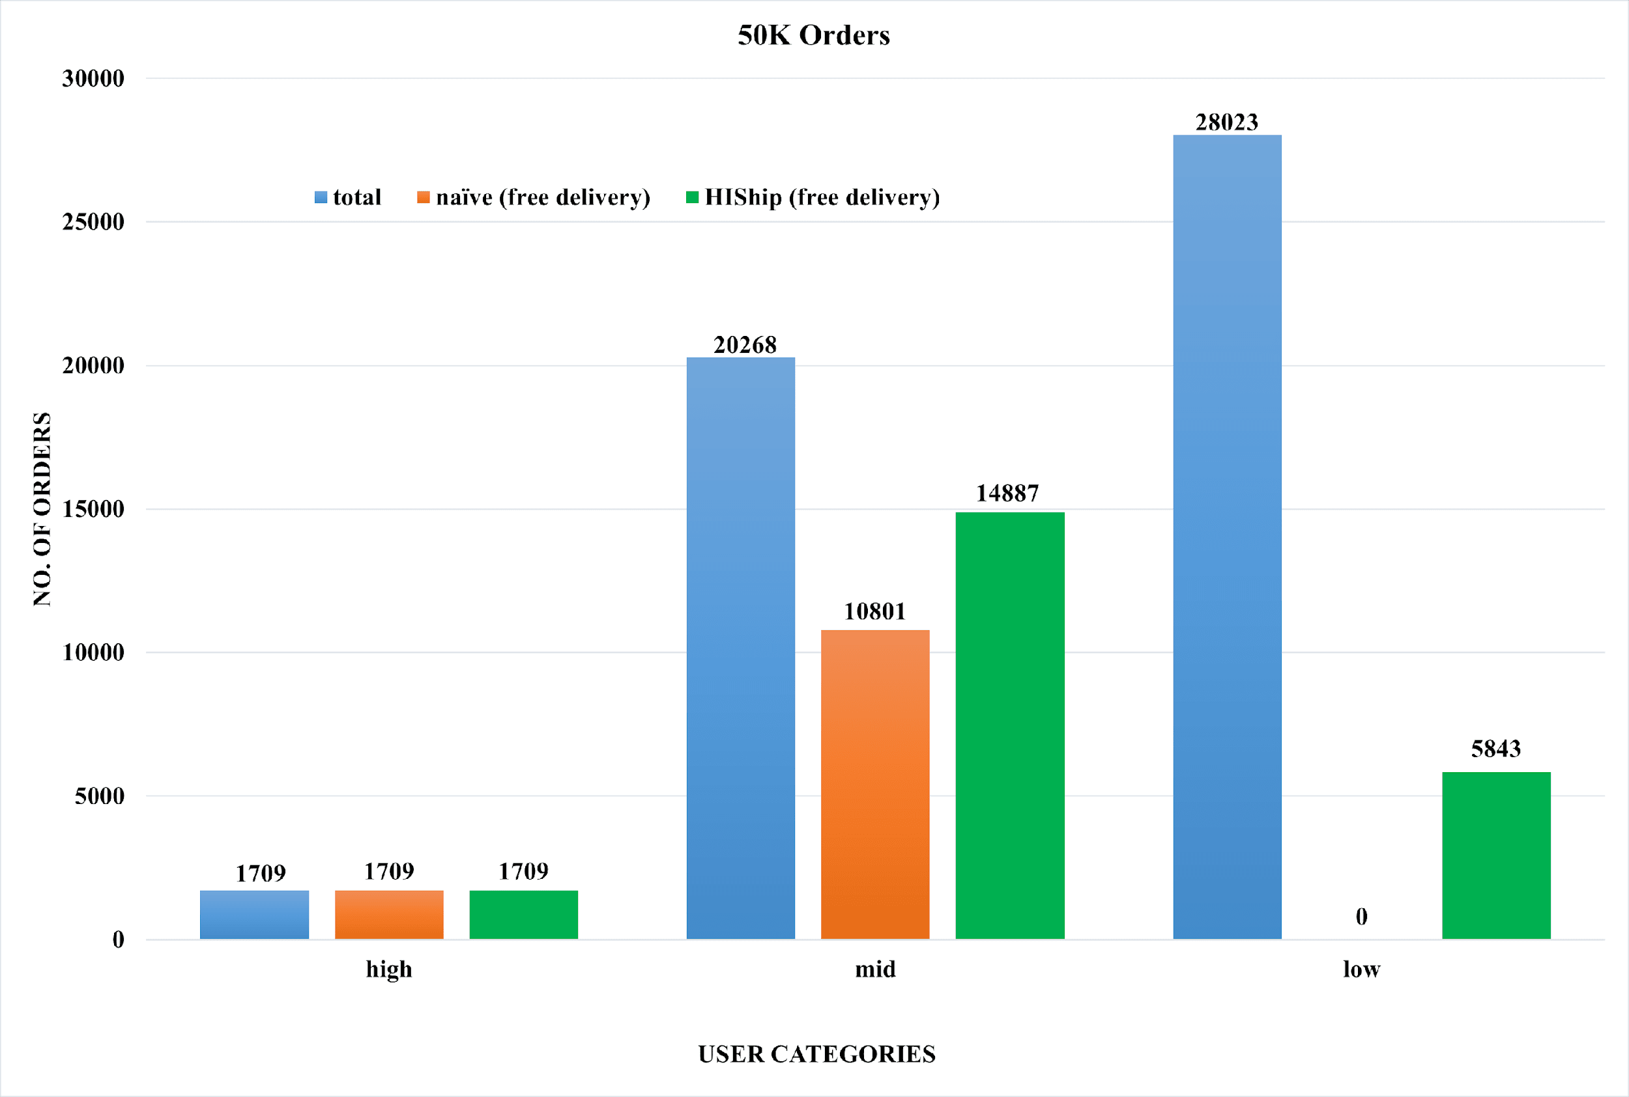

Figure 6: 50K Orders Classification & Delivery Eligibility: HIShip vs Naïve

In Figure 6, a dataset of 50K orders has been categorized into three distinct groups based on their transaction amounts. The first category comprises high-value orders, the second encompasses mid-value orders, and the remainder falls under the low-value order category. In our graphical representation, the sky blue bars denote the total number of orders, while the orange bars represent the conventional approach of providing free delivery. In contrast, the green bars illustrate the number of orders benefiting from our proposed algorithm's free delivery system. In this instance of 50K orders, In the uppermost order category (high category), it is noteworthy that both algorithms yield identical results, specifically, the provisioning of 1709 free delivery orders out of a total of 1709. In the middle category of orders, we found that the naïve approach delivers 10,801 products without the shipping fee. At the same time, the proposed algorithm provides 14,887 orders without delivery charges in 20268 mid-category orders. Our approach shows an exciting result in low-budget orders, and the naïve approach charges a shipping charge for every order. At the same time, the proposed algorithm provides 5843 orders, which is more efficient than the naïve approach.

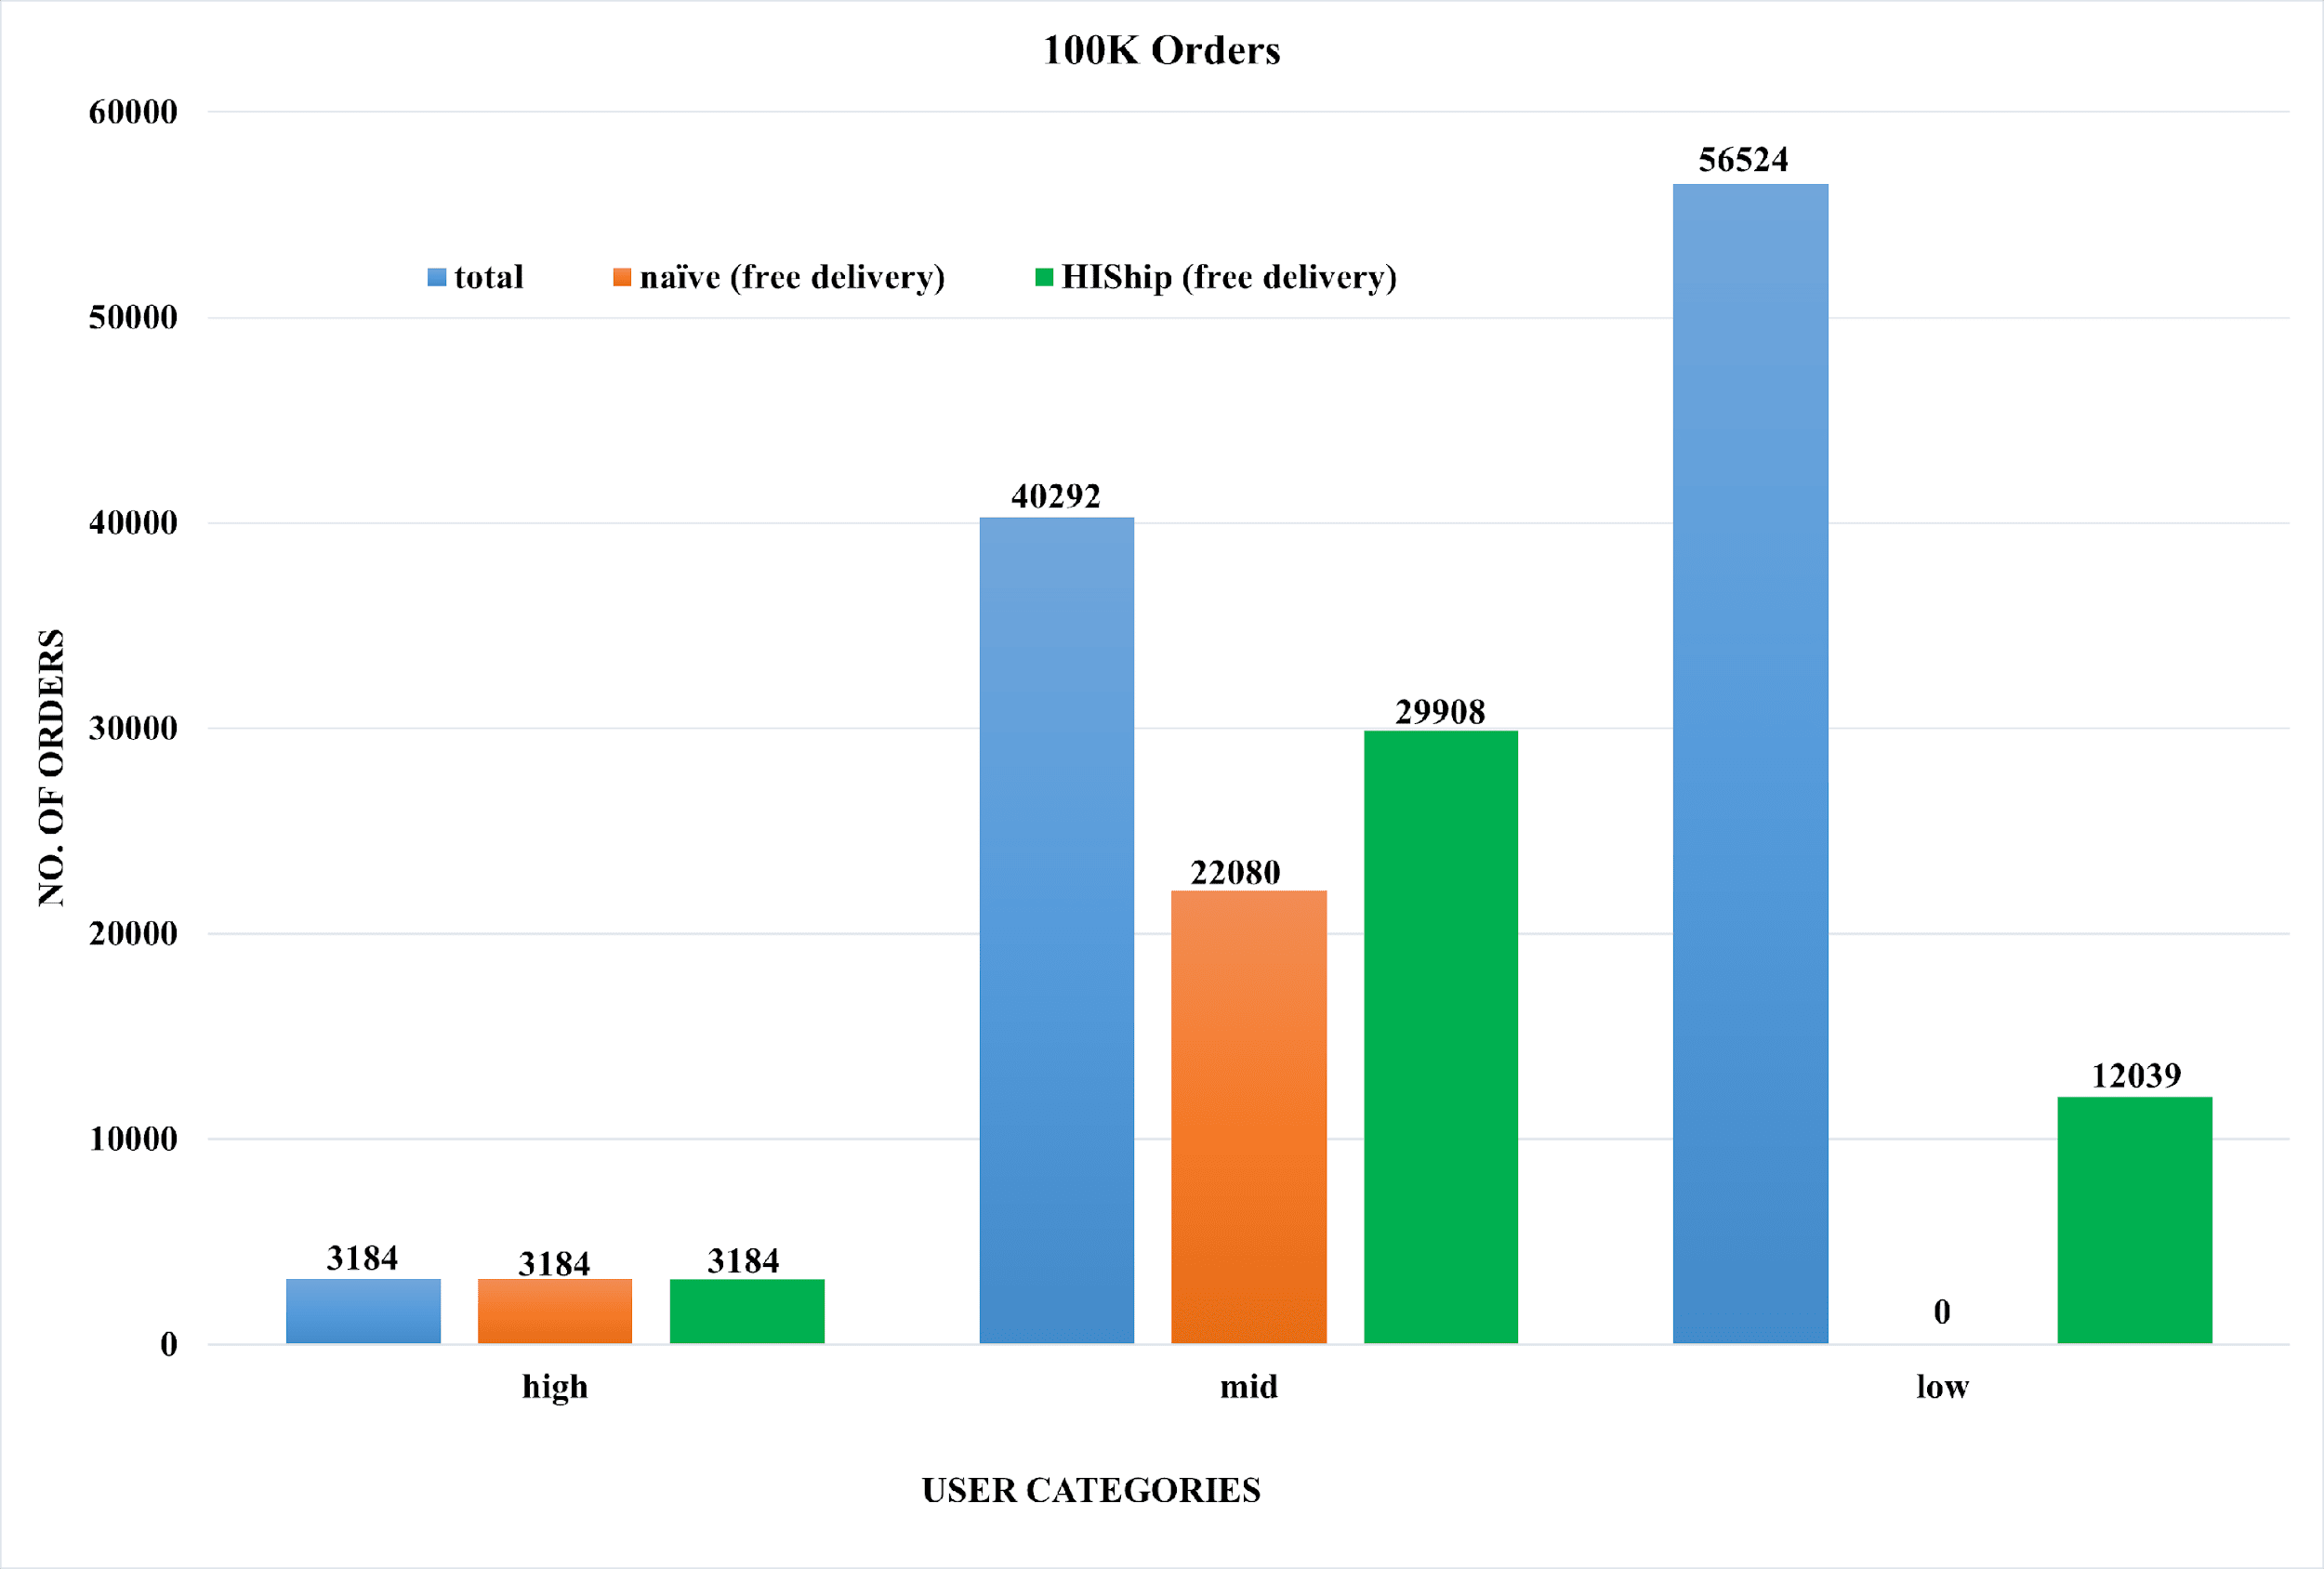

Figure 7: 100K Orders Classification & Delivery Eligibility: HIShip vs Naïve

In Figure 7, a dataset of 100K is classified orders into three distinct categories based on transaction value: high-value, mid-value, and low-value. The graph presents this stratification, with sky blue bars indicating total order counts, orange bars representing counts of orders eligible for free delivery using a traditional approach, and green bars depicting orders qualifying for free delivery under our innovative algorithm. This visual representation offers valuable insights into order distribution and the potential enhancements our proposed algorithm brings to our delivery strategy, enabling us to make more informed decisions for optimizing delivery efficiency. In the high-order category, both algorithms perform the same results. But in the case of the mid category, the naïve algorithm gives 55% of orders without imposing any shipping fee, while our proposed algorithm provides 74% of products without delivery fees. The proposed algorithm offers significant advantages, particularly for orders falling within the third category, making it notably remarkable in this context. In the low-budget segment encompassing 100K instances, our proposed methodology facilitated the successful fulfillment of 12,039 orders without incurring any shipping charges for the distribution of products. At the same time, in the same category, the naïve algorithm does not provide a single order without a shipping fee. Our proposed algorithm is low-budget

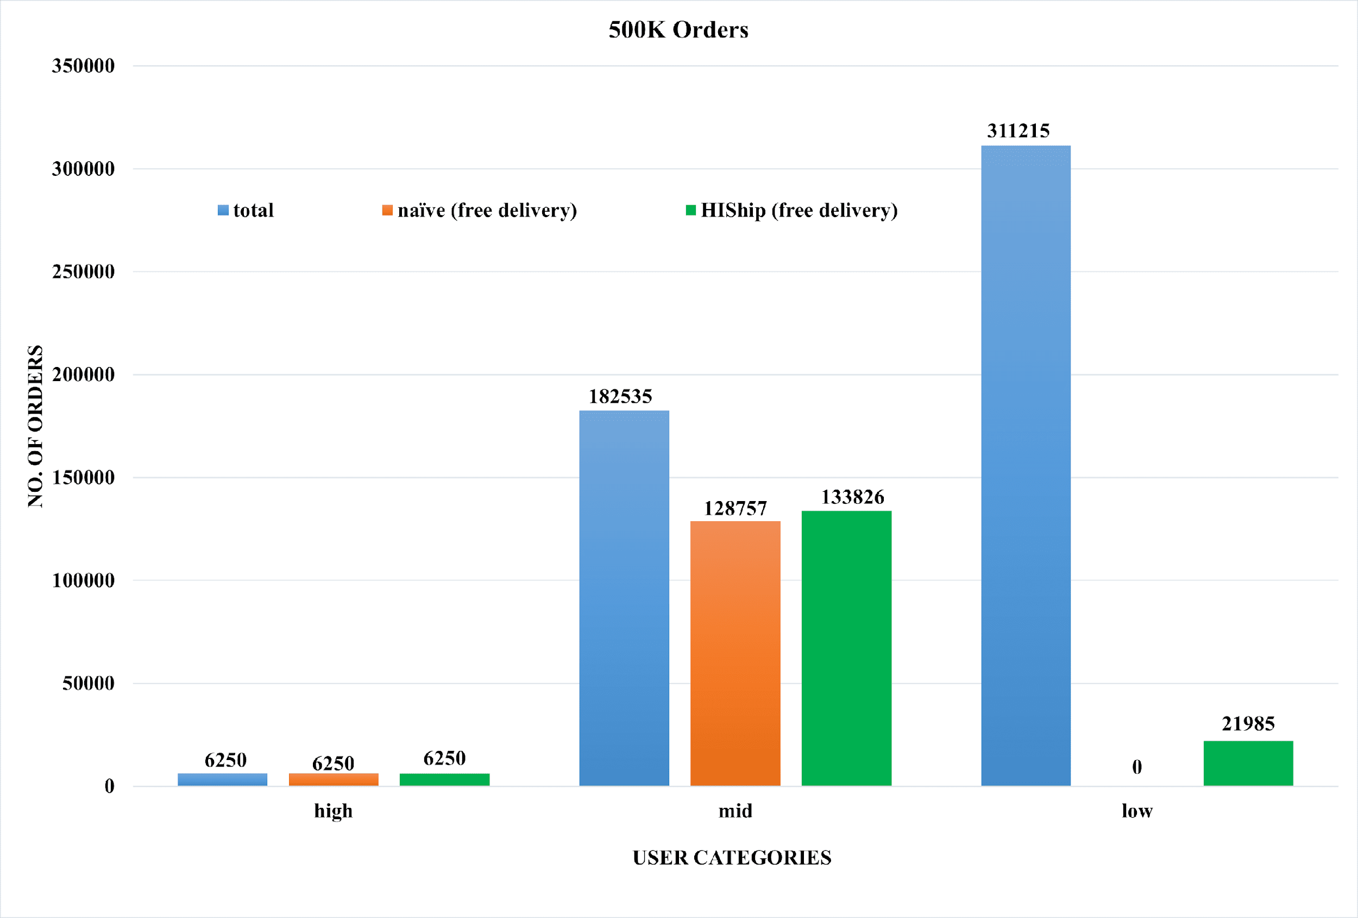

Figure 8: 500K Orders Classification & Delivery Eligibility: HIShip vs Naive

In Figure 8, a dataset of 500K orders is divided into three distinct categories based on their transaction amounts. The initial category encompasses high-value orders, the second category comprises mid-value orders, and the remaining orders are categorized as low-value orders. In our graphical representation, we use sky blue to represent the total order count, while orange corresponds to the conventional or 'naïve' approach of offering free delivery. The green bars in the graph illustrate the number of orders for which free delivery was granted when employing our proposed algorithm. In this instance of 500K orders, we applied both algorithms to ascertain the number of orders that realize the advantage of exempted shipping charges. We get the same results in the high-budget category for both approaches. Within the mid-budget order category, the conventional or "naïve" approach resulted in 70.5% of the total orders being fulfilled without incurring shipping fees. In contrast, our innovative proposed approach achieved a rate of 73% of the total orders, demonstrating an improvement in this aspect. Our approach is more efficient in the last low-budget category of orders. For this category of orders, the naïve algorithm is not more efficient. It provides non-customers with free delivery of products, while our approach provides 7% orders of the total orders without paying any shipping fee.

1. Conclusion

We developed the HIShip method to provide users with free delivery based on their past orders. The test of our algorithm on the TPC-H dataset demonstrated excellent performance, with a significant increase in free-delivery orders. HIShip method has led to an increase in the free delivery orders by 21.5% in the mid-budget orders. Furthermore, it improved th free delivery orders by 21.06% in the low-budget category. It has stimulated customer engagement by incentivizing those who place lower-priced orders, thus fostering increased free delivery. At the same time,  HIShip is fair to those sellers who want to sell their products online but whose products are in the low-cost range (less than the set threshold). In the end, integrating HIShip with existing online shopping platforms could also benefit the platform owner as they would attract more traffic.

# References

|  |  |
| --- | --- |
| [1] | India Brand Equity Foundation, "E-commerce Industry in India," [Online]. Available: https://www.ibef.org/industry/ecommerce. [Accessed 1 09 2023]. |
| [2] | H. P. Bulsara and P. S. Vaghela, "Blockchain Technology for E-commerce Industry," *International Journal of Advanced Science and Technology,* vol. 29, pp. 3793 - 3798, 2020. |
| [3] | M. X. Teo, T. A. Maen and A.-M. Qusay, "Blockchain technology in E-commerce platform," *International Journal of Management,* vol. 11, pp. 1688--1697, 2020. |
| [4] | Hotea Solutions, "TPC-H Vesion 2 and Version 3," 14 09 2023. [Online]. Available: https://www.tpc.org/tpch/. |
| [5] | B. Melyssa, B. Jorge and F. Pedro, "An overview of decision support benchmarks: TPC-DS, TPC-H and SSB," *New Contributions in Information Systems and Technologies,* vol. 1, pp. 619-628, 2015. |
| [6] | W. Gavin, "Ethereum: A secure decentralised generalised transaction ledger," *Ethereum project yellow paper,* 2014. |
| [7] | K. Kamal, S. Sarvesh and U. Shankar, "A journey from commit processing in distributed databases to consensus in blockchain," in *IEEE 38th International Conference on Data Engineering (ICDE)*, Kuala Lumpur, Malaysia, 2022. |
| [8] | L. Guang, S. Lifei and Z. Dongyuan, "Free or calculated shipping: Impact of delivery cost on supply chains moving," *International Journal of Production Economics,* 2023. |
| [9] | A. Ali and A. a. R. A. Fadwa, "Enhancement of E-commerce Service by Designing Last Mile Delivery Platform," *Computer Systems Science \& Engineering,* vol. 42, 2022. |
| [10] | M. A. Yunifa, N. Hani, H. Sri, M. S. N. Supeno and H. Mochamad, "Decentralized Tourism Destinations Rating System Using 6AsTD Framework and Blockchain," in *2020 International Conference on Smart Technology and Applications (ICoSTA)*, Surabaya, Indonesia, 2020. |
| [11] | S. Andreas, R. N. Sina, P. Lucas, W. Severin, B. Thomas, R. Lawrence and S. Burkhard, "EUREKA – A Minimal Operational Prototype of a Blockchain-based Rating and Publishing System," in *2019 IEEE International Conference on Blockchain and Cryptocurrency (ICBC)*, Seoul, Korea (South) , 2019. |
| [12] | H.-T. Wu, S. Yi-Jen and H. Wu-Chih, "A Study on Blockchain-Based Circular Economy Credit Rating System," in *International Conference on Security with Intelligent Computing and Big-data Services*, 2017. |
| [13] | Y. Ching-Nung, C. Yi-Cheng, C. Shih-Yu and W. Song-Yu, "A reliable e-commerce business model using blockchain based product grading system," in *In 2019 IEEE 4th International Conference on Big Data Analytics (ICBDA)*, Suzhou, China, 2019. |
| [14] | S. Valerii and B. Maxim, "Stay some more and buy? Modeling the effects of visit time on online shopping purchases," in *International Workshop on Data Mining and Knowledge Engineering*, 2020, pp. 111--118. |
| [15] | W. Robin, "The influence of user affect in online information disclosure," *The Journal of Strategic Information Systems,* vol. 22, no. 2, pp. 157-174, 2013. |
| [16] | Z. Liu and Z. Li, "A blockchain-based framework of cross-border e-commerce supply chain," *International Journal of Information Management,* vol. 52, 2020. |
| [17] | J.-S. C. a and C.-C. Ting, "Will you spend more money and time on internet shopping when the product and situation are right?," *Computers in Human Behavior,* vol. 27, no. 1, pp. 203-208, 2011. |
| [18] | B.-A. Rafael, M. Leng and P. Mahmut, "Online retailers’ promotional pricing, free-shipping threshold, and inventory decisions: A simulation-based analysis," *European Journal of Operational Research,* vol. 230, pp. 272--283, 2013. |
| [19] | N. T. Koukova, J. Srivastava and M. Steul-Fischer, "The effect of shipping fee structure on consumers’ online evaluations and choice," *Journal of the Academy of Marketing Science,* vol. 40, pp. 759--770, 2012. |
| [20] | N. Satoshi, "Bitcoin: A peer-to-peer electronic cash system," *Decentralized business review,* 2008. |
| [21] | Ethereum Foundation, "Remix," [Online]. Available: https://remix-project.org/. [Accessed 3 09 2023]. |